

***School of Mechanical & Manufacturing Engineering (SMME), National University of Science and Technology (NUST), Sector H-12,***

***Islamabad***

ED: Engineering Drawing

AE-01

**Name: Muhaddasa Sohail**

**CMS: 455387**

**Subject: Engineering drawing (LAB)**

*Department of Aerospace Engineering*

*School of Mechanical and Manufacturing Engineering National University of Science and Technology*

*H12, Islamabad*

**Drawing no.1**

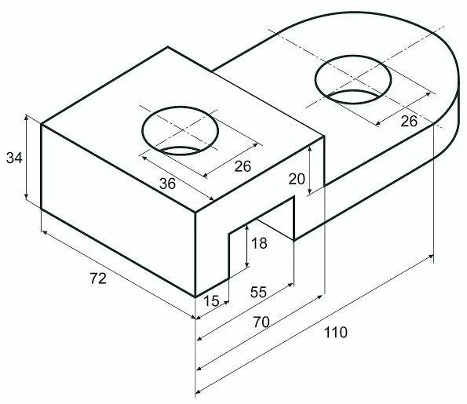

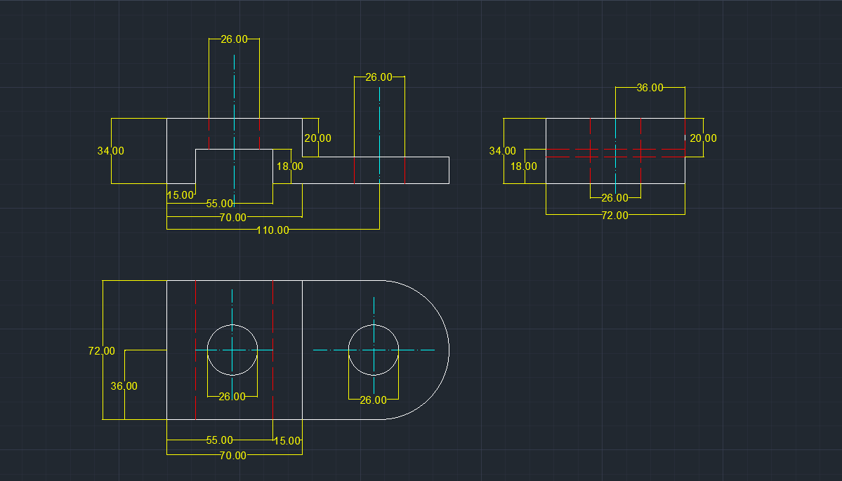**Drawing no.1 ( Auto Cad Drawing)**

https://web.autocad.com/acad/me/sid/shares/drawings/bda15908-ce12-43d7-8875-e99c1f7c45e0/editor

**Drawing no.2**

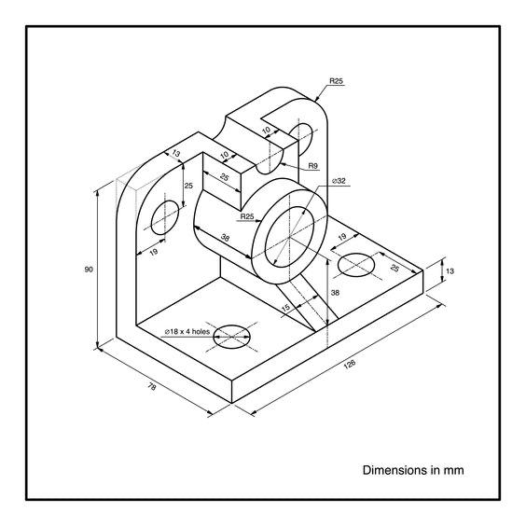

**Drawing no.2 ( Auto Cad Drawing)**

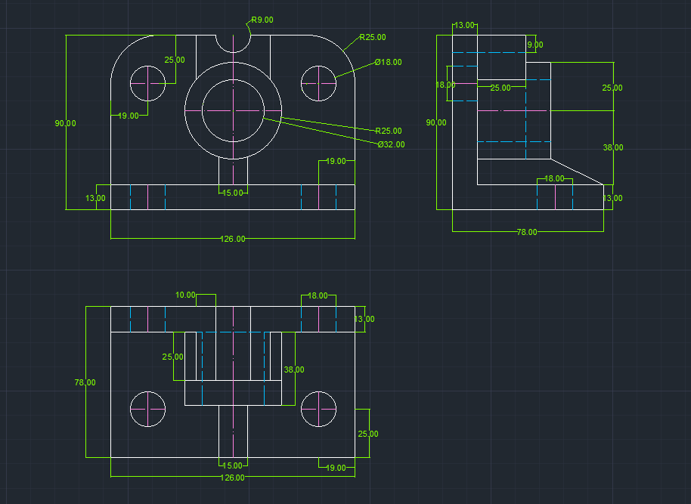

https://web.autocad.com/acad/me/sid/shares/drawings/f172ffd8-a98f-4cb8-94ed-38a939fdfe3

2/editor

**Drawing no.3**

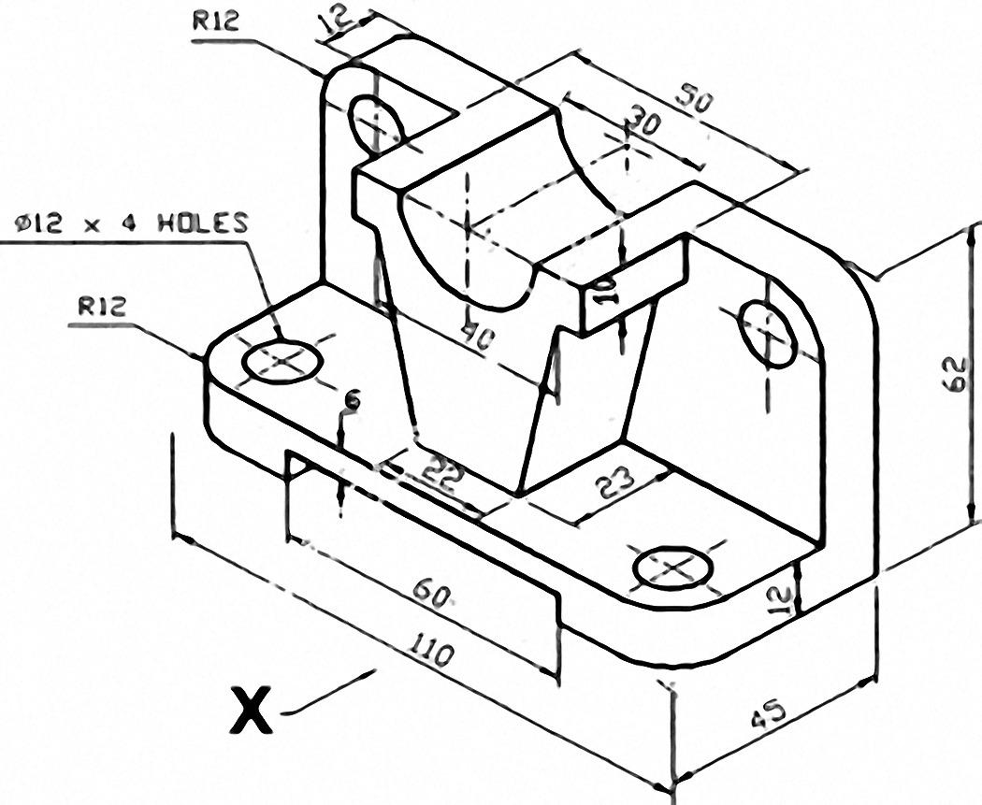

**Drawing no.3 ( Auto Cad Drawing)**

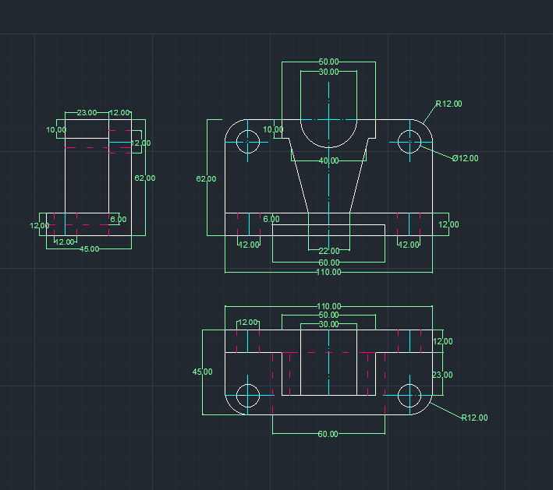https://web.autocad.com/acad/me/sid/shares/drawings/fae7a378-9d4f-4dd8-b3b1-a76fe0aa485d/editor